HOMEplus Smart Home System

**Use Case Specification**

Document Number: SRS-02

Team Name: Stuttgart

Project Sponsor: SER415

# **Approvals**

|  |  |  |  |  |
| --- | --- | --- | --- | --- |
| Prepared by:  Jared Huber, Documentation 9/20/17 |  |  | Reviewed by:  Jacob Wilkens, Consistency Manager 9/23/17 |  |
| Reviewed by:  Alexander Nordstrom, Review Coordinator 9/23/17 |  |  | Reviewed by:  Allison Olszowka, Meetings Coordinator 9/23/17 |  |
| Approval by:  David Arnold, Management 9/24/17 |  |  | Approval by:  Name, Title |  |

# **Revision History**

|  |  |  |  |
| --- | --- | --- | --- |
| **Date** | **Revision** | **Description** | **Author** |
| 9/19/17 | 1.0 | Transfer data to formal SRS document | Jared Huber |
| 9/20/17 | 1.1 | Incorporate activity diagrams | Jared Huber |
| 10/2/17 | 1.2 | Incorporate feedback by expanding on use case variations | Alex Nordstrom |
|  |  |  |  |

© Stuttgart. All rights reserved. No part of this copyrighted work may be reproduced, modified or distributed in any form or by any means or stored in any database or retrieval system, without the prior written permission of Stuttgart. Violation of copyright carries civil and criminal penalties. ASU has permission to use this document for an educational purposes it deems necessary.

# **Table of Contents**

**Approvals** **2**

**Revision History** **3**

**Table of Contents** **4**

**Introduction** **6**

Purpose 6

References 6

Glossary 6

Acronyms and Abbreviations 6

**Object Catalog** **7**

Actor Catalog 7

Use Case Catalog 7

Use Case Diagram 8

Business Rules 8

**Use Case Specifications** **9**

Manage Data 9

Control Temperature 9

Manage Light 10

Manage Locks 11

Manage Outlets 11

Manage Voice Activated Speaker 12

Manage Motion Camera Stream 13

Manage Home Inventory 13

**Analysis Model** **15**

Activity Diagram for Manage Data <UC-SER415-01> 15

Activity Diagram for Control Temperature <UC-SER415-03> 16

Activity Diagram for Manage Lights <UC-SER415-04> 17

Activity Diagram for Manage Locks <UC-SER415-05> 18

Activity Diagram for Manage Outlets <UC-SER415-06> 19

Activity Diagram for Manage Voice Activated Speakers <UC-SER415-07> 20

Activity Diagram for Manage Motion Camera Stream <UC-SER415-08> 21

Activity Diagram for Manage Inventory <UC-SER415-10> 22

Activity Diagram for Login 23

**Open Issues** **23**

**Appendix A** **24**

# **Introduction**

## **Purpose**

The Purpose of this document is to outline the requirements for the HOMEplus Smart Home System to be developed for ASU. This document is to be ratified by both the primary and secondary stakeholders so as to verify and test the system being developed on a real-time basis.

## **References**

|  |  |
| --- | --- |
| **Item** | **Description** |
| Vision Document | This document helps to identify features, needs, and stakeholders of the solution being developed and provides a link between the developers and the client. |

## **Glossary**

|  |  |
| --- | --- |
| **Item** | **Description** |
| Hub | The HOMEplus hub is the main processing unit for the smart home system. |

## **Acronyms and Abbreviations**

|  |  |
| --- | --- |
| **Item** | **Description** |
| ASU | Arizona State University |
| OI | Open Issue |
| UC | Use Case |

# **Object Catalog**

## **Actor Catalog**

|  |  |  |  |
| --- | --- | --- | --- |
| **ID** | **Title** | **Type** | **Goal** |
| A-1 | External User | User | Able to utilize smart home technology to enhance convenience |
| A-2 | Hub | Component | Interface the user to all smart devices and gather information about user preferences |
| A-3 | Web/Mobile Application | Component | Remotely interface the user with the HOMEplus hub |
| A-4 | Server | External System | Store all user preferences |
| A-5 | Smart Device | Component | Manipulate and record data corresponding to specific device |

## **Use Case Catalog**

|  |  |  |  |  |  |
| --- | --- | --- | --- | --- | --- |
| **UC-ID** | **Title** | **Business**  **Priority** | **Complexity** | **Primary Actor** | **Description** |
| UC-SER415-01 | Manage Data | High | Hgih | Hub | Hub records data and determines user preferences |
| UC-SER415-03 | Control Temperature | Hgh | Low | External User | User controls temperature by use of web/mobile application or hub |
| UC-SER415-04 | Manage Lights | Medium | Medium | External User | User controls smart lights by use of web/mobile application or hub |
| UC-SER415-05 | Manage Locks | Medium | Medium | External User | User controls locks by use of web/mobile application or hub |
| UC-SER415-06 | Manage Outlets | Low | Medium | External User | User controls outlets by use of web or mobile application. |
| UC-SER415-07 | Manage Voice Activated Speaker | Medium | High | External User | User gives commands by voice. |
| UC-SER415-08 | Manage Motion Camera Stream | High | Medium | External User | User controls motion doorbell camera by use of web/mobile application or hub |
| UC-SER415-10 | Manage Home Inventory | High | Low | External User | Manage home inventory including adding and removing items as well as viewing current inventory. |

## **Use Case Diagram**

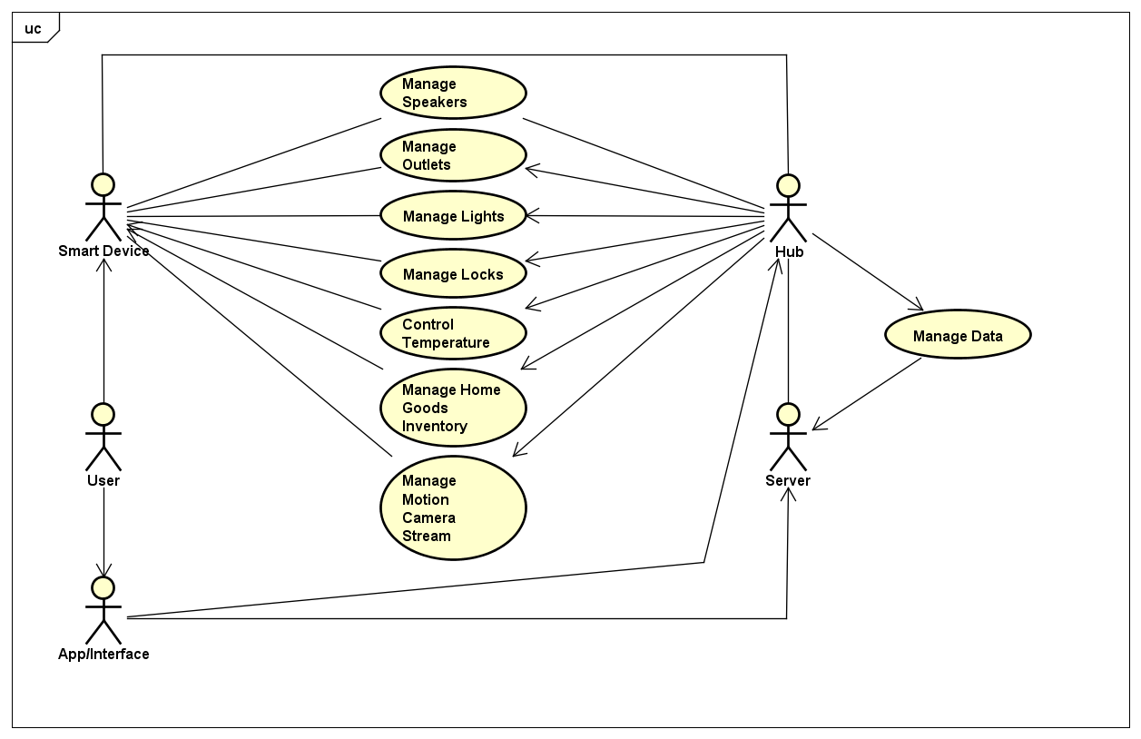

## **Business Rules**

1. HOMEplus smart home system is a closed system, it is not designed to interface with existing hardware or software.

# **Use Case Specifications**

## Manage Data

**Use Case: UC-SER415-01**

**Objective:** Hub collects data from the user either directly or via smart devices and stores this data on the server

**Primary Actor:** Hub

**Dependencies:** None

**Trigger:** External User declares preferences

**Secondary Actors:** Server, External User, Smart Device

**Precondition(s):**

* Hub has connectivity to smart devices
* User provides initial data to hub

**Post Condition(s):**

* Success end condition(s)
  + Hub defines user preferences
  + Hub stores data securely on server
* Failure end condition:
  + Preferences not determined

**MAIN SUCCESS SCENARIO**

1. User accesses the HOMEplus application through the hub, or web/mobile app.
2. User enters login credentials and is successfully authenticated by the server.
3. User provides preferences for all connected smart devices
4. Hub registers and stores data to server

**VARIATIONS**

* User does not provide preferences so the system must learn over time and create its own data to manage.

## Control Temperature

**Use Case: UC-SER415-03**

**Objective:** User desires to set temperature to personal preferences.

**Primary Actor:** External User

**Dependencies:** None

**Trigger:** User adjusts temperature settings within the HOMEplus application.

**Secondary Actors:** Hub, App/Interface, Server, Thermostat

**Precondition(s):**

* User must have access to the HOMEplus application and be authenticated.

**Post Condition(s):**

* Success end condition
  + User sets temperature preferences through the HOMEplus application and if the current household temperature is greater than user’s preference, the thermostat runs air conditioner until desired temperature is reached, otherwise the thermostat turns on the heater until desired temperature is reached.
* Failure end condition:
  + Current household temperature does not reflect user preference.

**MAIN SUCCESS SCENARIO**

1. User accesses the HOMEplus application through the hub, or web/mobile app.
2. User enters login credentials and is successfully authenticated by the server.
3. User selects Temperature Control icon/menu and adjusts temperature.
4. The hub communicates instructions to the thermostat.
5. The thermostat turns on the air conditioner during the time where the household temperature is greater than user’s preference, and turns on the heater during times where the household temperature is less than user’s preference.

**VARIATIONS**

* Server acts as intermediary between user and hub when user is not connected to home network.
  1. User accesses the HOMEplus application through the web/mobile app.
  2. User enters login credentials and is successfully authenticated by the server.
  3. User selects Temperature Control icon/menu and adjusts temperature.
  4. The server communicates instructions to the hub.
  5. The hub communicates instructions to the thermostat.
  6. The thermostat turns on the air conditioner during the time where the household temperature is greater than user’s preference, and turns on the heater during times where the household temperature is less than user’s preference.

## Manage Light

**Use Case: UC-SER415-04**

**Objective:** User controls smart lights by use of web or mobile application.

**Primary Actor:** External User

**Dependencies:** None

**Trigger:** User accesses the web or mobile application and selects lights

**Secondary Actors:** Hub, App/Interface, Server

**Precondition(s):**

* User must have access to the HOMEplus application and be authenticated.

**Post Condition(s):**

* Success end condition(s)
  + User is able to toggle light
  + Hub syncs light state to server
  + User is able to view current state of lights
* Failure end condition:
  + Hub fails to connect to light

**MAIN SUCCESS SCENARIO**

1. User accesses the HOMEplus application through the hub, web, or mobile app
2. User enters login credentials and is successfully authenticated by the server
3. User selects the lights icon
4. User selects which light to control
5. If the user is not connected to their home network, the server communicates instructions to the hub.
6. Hub syncs with server
7. Current state of lights is updated on user interface

**VARIATIONS**

* User toggles lights by use of switch
  1. User toggles light by use of switch
  2. Hub is notified of change and updates state of light
  3. Hub syncs with server
* Lights are triggered automatically by user-defined schedule
  1. At scheduled time, hub sets light to appropriate state
  2. Hub updates state of light
  3. Hub syncs with server

## Manage Locks

**Use Case: UC-SER415-05**

**Objective:** User controls locks by use of web or mobile application.

**Primary Actor:** External User

**Dependencies:** None

**Trigger:** User accesses the web or mobile application and selects locks

**Secondary Actors:** HomePLUS hub, App/Interface, Server

**Precondition(s):**

* User must have access to the HOMEplus application and be authenticated.

**Post Condition(s):**

* Success end condition(s)
  + User is able to unlock lock
  + Hub syncs lock state to server
  + User is able to view current state of locks
  + Lock is automatically relocked after door is closed
* Failure end condition:
  + Hub fails to connect to lock

**MAIN SUCCESS SCENARIO**

1. User accesses the HOMEplus application through the hub, web, or mobile app
2. User enters login credentials and is successfully authenticated by the server
3. User selects the locks icon
4. User selects which lock to control
5. If the user is not connected to their home network, the server communicates instructions to the hub.
6. Hub syncs with server
7. Current state of locks is updated on user interface
8. User opens door
9. User closes door
10. Hub relocks the lock
11. Hub syncs with server
12. Current state of locks is updated on user interface

**VARIATIONS**

* User activates locks by use of latch or key.
  1. User activates locks by user of latch or key
  2. Hub is notified of change and updates state of lock
  3. Hub syncs with server
* Lock is automatically opened by smartphone proximity and user opens door.
  1. Hub determines user to be in proximity to lock through communication with smartphone location services.
  2. Hub unlocks lock
  3. Hub syncs with server
  4. User opens door
  5. User closes door
  6. Hub relocks the lock
  7. Hub syncs with server
* Lock is automatically opened by smartphone proximity, user does not open door.
  1. Hub determines user to be in proximity to lock through communication with smartphone location services.
  2. Hub unlocks lock
  3. Hub syncs with server
  4. User does not open door within 20 seconds
  5. Hub relocks lock
  6. Hub syncs with server

## Manage Outlets

**Use Case: UC-SER415-06**

**Objective:** User controls outlets by use of web or mobile application.

**Primary Actor:** External User

**Dependencies:** None

**Trigger:** User accesses the web or mobile application and selects outlets

**Secondary Actors:** Hub, App/Interface, Server

**Precondition(s):**

* User must have access to the HOMEplus application and be authenticated.

**Post Condition(s):**

* Success end condition(s)
  + User is able to disable/enable outlet
  + Hub syncs outlet state to server
  + User is able to view current state of outlets
* Failure end condition:
  + Hub fails to connect to outlet

**MAIN SUCCESS SCENARIO**

1. User accesses the HOMEplus application through the hub, web, or mobile app
2. User enters login credentials and is successfully authenticated by the server
3. User selects the outlets icon
4. User selects which outlet to control
5. If the user is not connected to their home network, the server communicates instructions to the hub.
6. Hub syncs with server
7. Current state of outlet is updated on user interface

**VARIATIONS**

* Outlet state is toggled based on user-defined scheduling
  1. At scheduled time, hub sets outlet to appropriate state
  2. Hub updates state of outlet
  3. Hub syncs with server

## Manage Voice Activated Speaker

**Use Case: UC-SER415-07**

**Objective:** User controls smart devices with commands by voice.

**Primary Actor:** External User

**Dependencies:** None

**Trigger:** User speaks trigger phrase: “HOMEplus”

**Secondary Actors:** Hub, App/Interface, Server

**Precondition(s):**

* User must be clearly audible by speaker.

**Post Condition(s):**

* Success end condition(s)
  + User speaks trigger phrase: “home plus”
  + Server is able to parse the audio
  + A function is carried out
  + An audio confirmation is sent over the speaker
* Failure end condition:
  + Audio cannot be parsed to a command
  + Command cannot be carried out
  + An error message is played through the speaker

**MAIN SUCCESS SCENARIO**

1. User speaks trigger phrase: “HOMEplus”
2. User speaks a valid command
3. Hub records audio and sends it to server
4. Server parses audio and sends command to hub
5. Hub carries out command through smart device
6. Hub syncs with server
7. Hub plays audio confirmation over speaker

**VARIATIONS**

* Speaker plays audio outside of direct user input, such as a scheduled reminder
  1. A time is reached for which the hub has a corresponding message
  2. Message is played over speakers

## Manage Motion Camera Stream

**Use Case: UC-SER415-08**

**Objective:** A user gets a notification that there is movement in the entryway or hears the doorbell ring and wants to check what triggered the notification.

**Primary Actor:** External User

**Dependencies:** None

**Trigger:** User accesses the web or mobile application and selects the video icon.

**Secondary Actors:** Hub, App/Interface, Server, Motion Camera

**Precondition(s):**

* User must have access to the HOMEplus application and be authenticated.

**Post Condition(s):**

* Success end condition
  + The user is able to access a live video feed of his entryway in order to ensure that there is not a suspicious person in his entryway.
* Failure end condition:
  + User is not able to view a live stream of his entryway.

**MAIN SUCCESS SCENARIO**

1. User accesses the HOMEplus application through the hub, web, or mobile app.
2. User enters login credentials and is successfully authenticated by the server.
3. User selects the video icon under the entry door section.
4. The hub communicates instructions to the motion camera to open a stream with the user’s device.

**VARIATIONS**

* Server acts as intermediary between user and hub when user is not connected to home network.
  1. User accesses the HOMEplus application through the hub, web, or mobile app.
  2. User enters login credentials and is successfully authenticated by the server.
  3. User selects the video icon under the entry door section.
  4. The server communicates instructions to the hub.
  5. The hub communicates instructions to the motion camera to open a stream with the user’s device.

## Manage Home Inventory

**Use Case: UC-SER415-10**

**Objective:** User desires to manage the home inventory by adding and removing items using a scanner functionality in the hub.

**Primary Actor:** External User

**Dependencies:** None

**Trigger:** User opens home inventory app on hub

**Secondary Actors:** Hub, App/Interface, Server

**Precondition(s):**

* User must have access to the HOMEplus application and be authenticated.

**Post Condition(s):**

* Success end condition(s)
  + User is able to add new item to home inventory
  + User is able to remove item from home inventory
  + Hub syncs inventory data with server
  + User is able to view current inventory
* Failure end condition:
  + User tries to add item that hub does not recognize

**MAIN SUCCESS SCENARIO**

1. User accesses the HOMEplus application through the hub
2. User enters login credentials and is successfully authenticated by the server
3. User opens inventory app
4. User scans new item to add to inventory
5. Hub recognizes item and catalogues item into inventory
6. Hub syncs with server

**VARIATIONS**

* User scans item to remove it from inventory
  1. User accesses the HOMEplus application through the hub
  2. User enters login credentials and is successfully authenticated by the server
  3. User opens inventory app
  4. User selects “Remove Item”
  5. User scans item to remove from inventory
  6. Hub recognizes item and removes item from inventory
  7. Hub syncs with server
* User accesses inventory for viewing via web/mobile app
  + - x : Users getInventory(x)
    - inventory’ = {a: item | b: inventory • (b , a)  Contains}
  1. User accesses the HOMEplus application from web/mobile app
  2. User is authenticated by server
  3. User opens “Inventory”
  4. User is able to see detailed status of inventory

# **Analysis Model**

## **Activity Diagram for** Manage Data **<UC-**SER415-01**>**

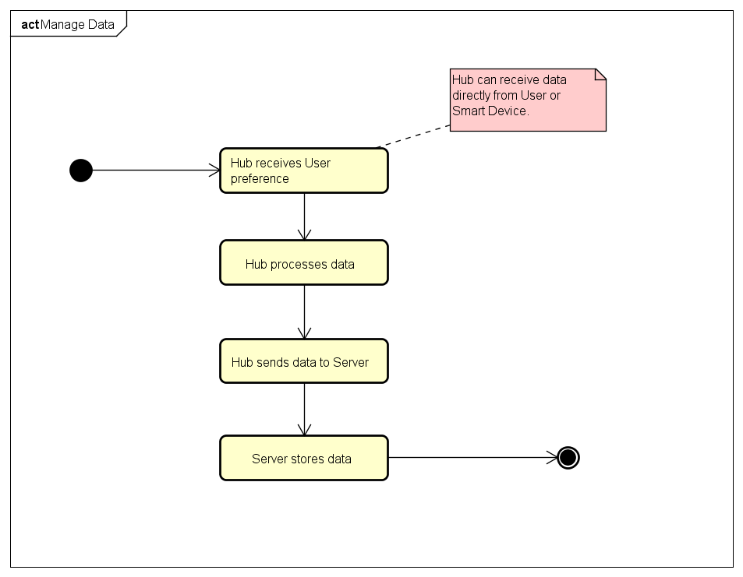

## Activity Diagram for Control Temperature <UC-SER415-03>

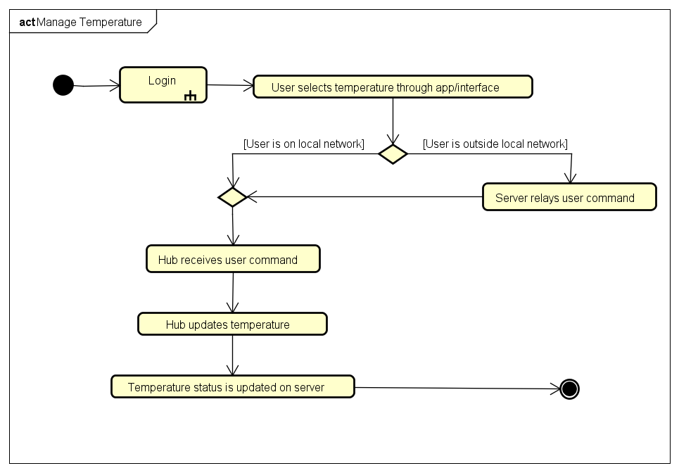

## Activity Diagram for Manage Lights <UC-SER415-04>

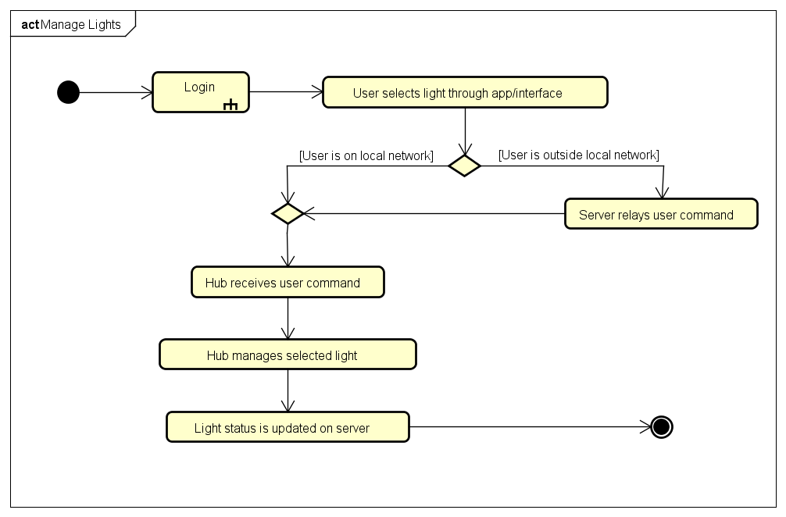

## Activity Diagram for Manage Locks <UC-SER415-05>

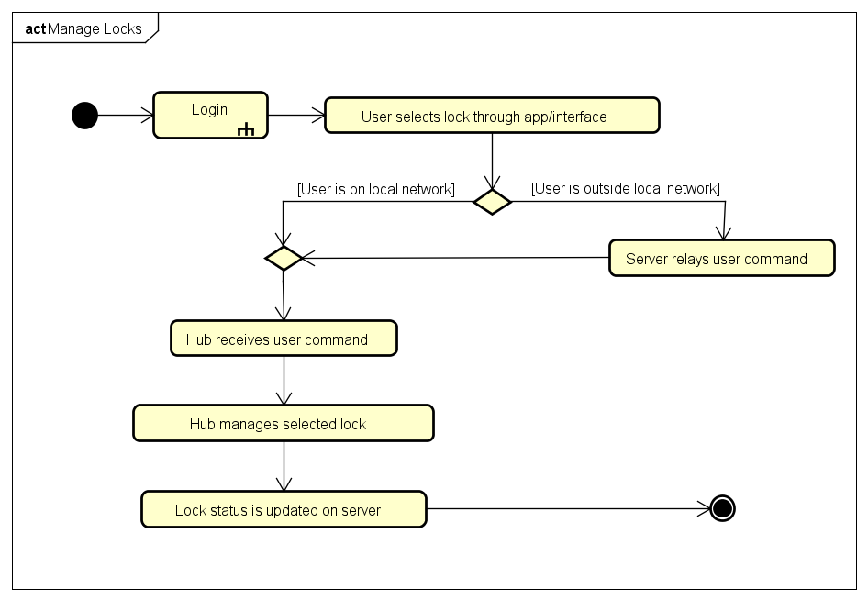

## Activity Diagram for Manage Outlets <UC-SER415-06>

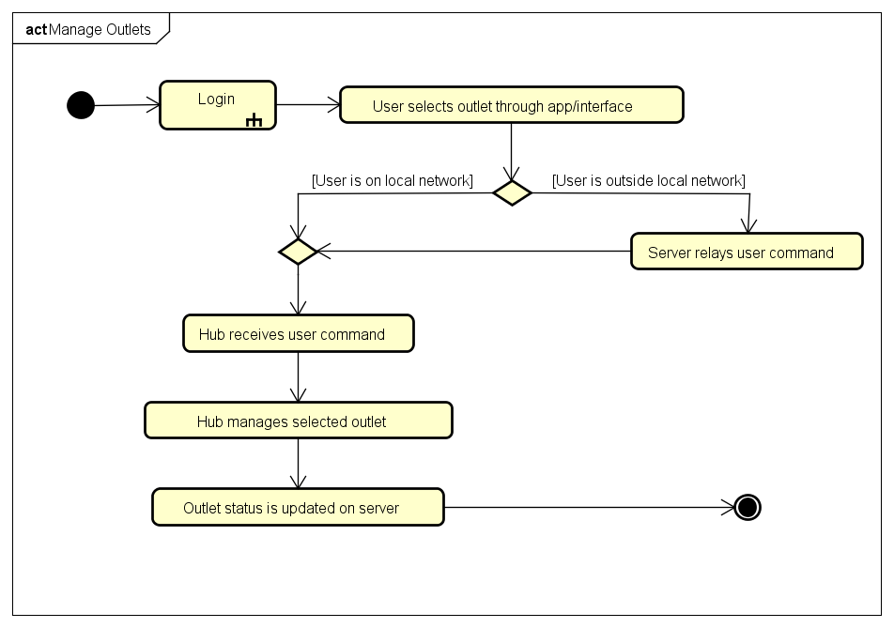

## Activity Diagram for Manage Voice Activated Speakers <UC-SER415-07>

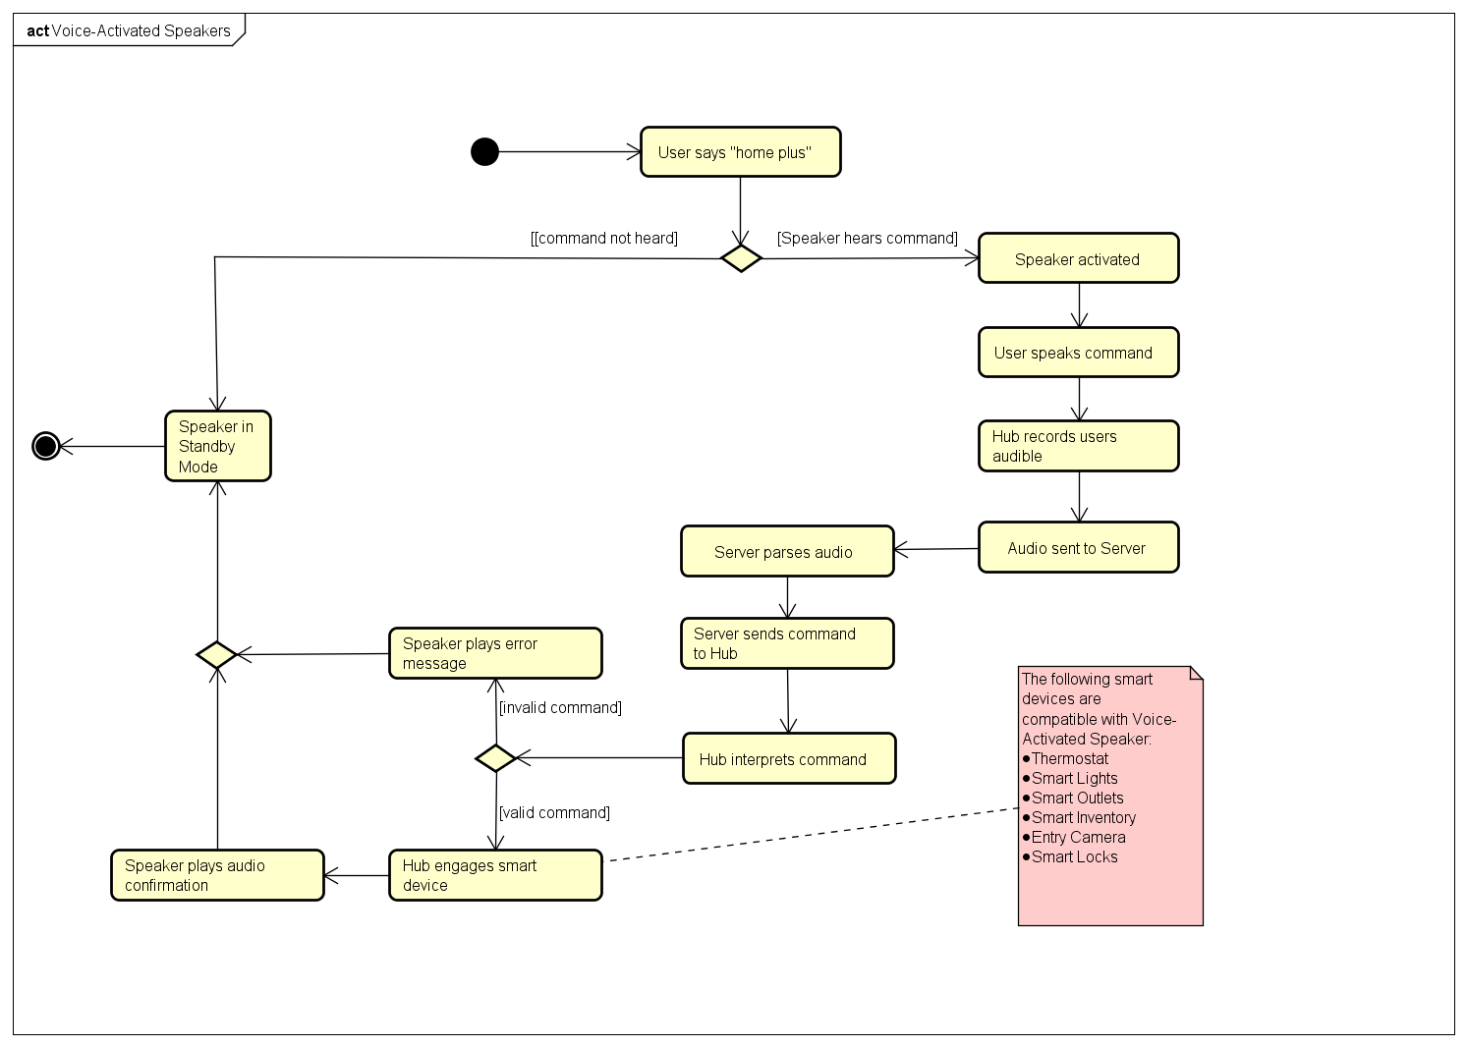

## Activity Diagram for Manage Motion Camera Stream <UC-SER415-08>

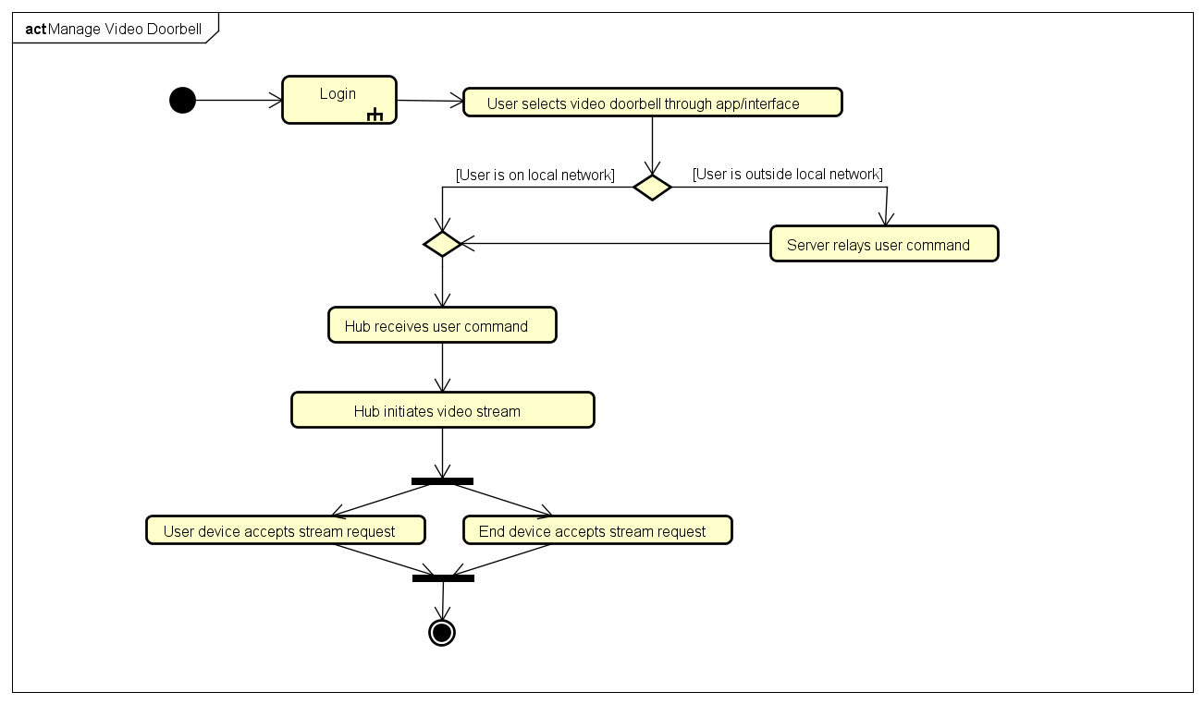

## Activity Diagram for Manage Inventory <UC-SER415-10>

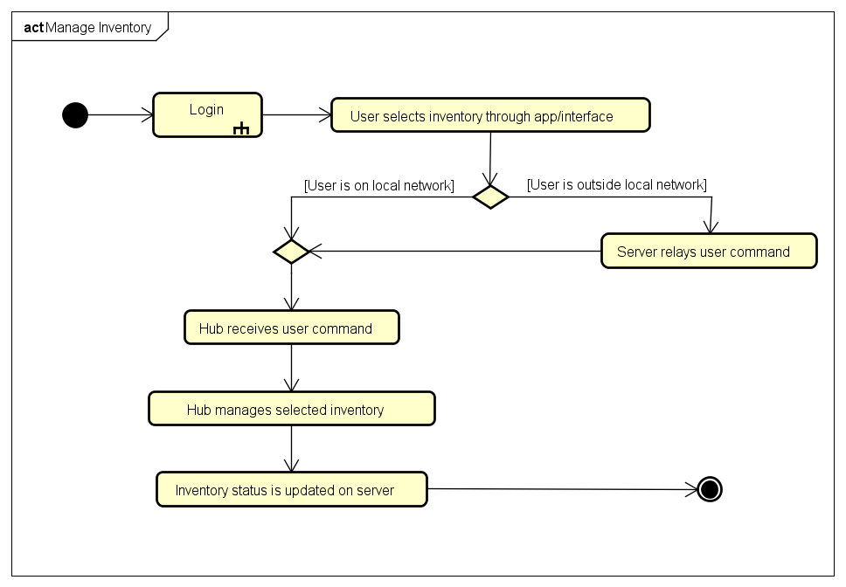

## Activity Diagram for Login

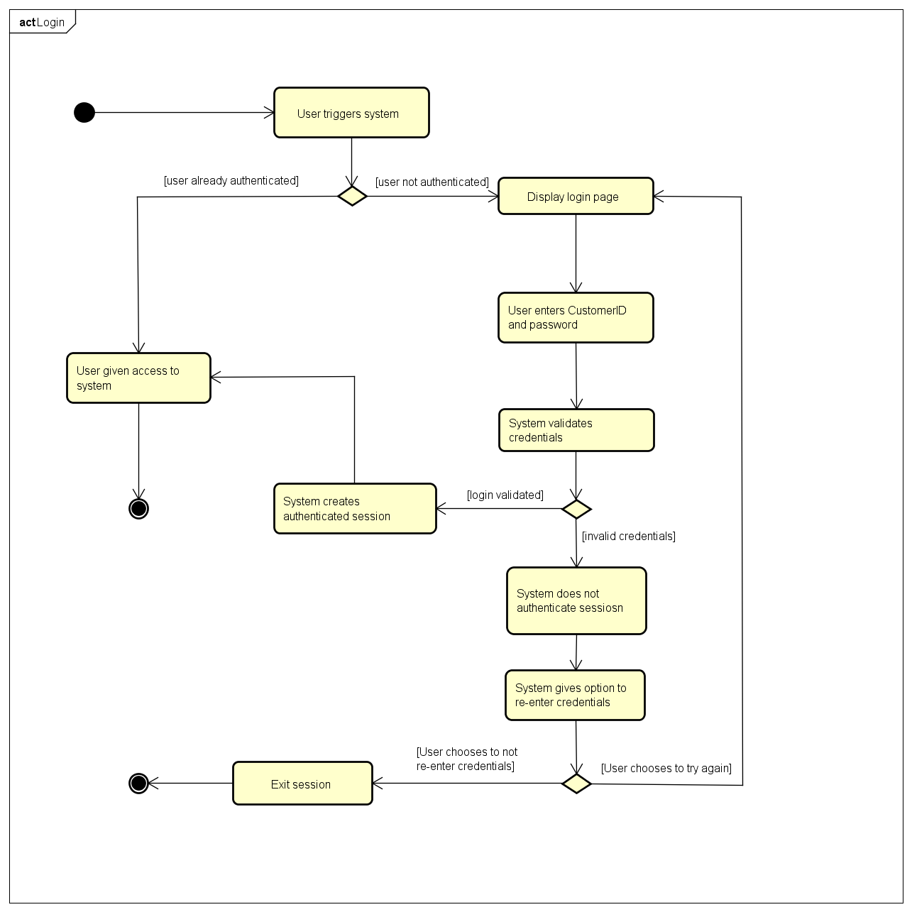

# **Open Issues**

|  |  |  |  |
| --- | --- | --- | --- |
| **ID** | **Description** | **State** | **Use Cases Affected** |
| OI-1 | Login use case not detailed. | Incomplete | Login |

# **Appendix A**